CubeSat EM Material Discharge Eval

Joshua Feldman

Michael Kim

Ian Poynter

Alejandro Torres

**Interface Control Document**

REVISION – Draft

28 September 2023

Interface Control Document

for

CubeSat EM Material Discharge Eval

Prepared by:

_____________________________

Author Date

Approved by:

_____________________________

Project Leader Date

_____________________________

John Lusher II, P.E. Date

_____________________________

T/A Date

**Change Record**

| **Rev.** | **Date** | **Originator** | **Approvals** | **Description** |
| --- | --- | --- | --- | --- |
| **-** | 9/28/2023 | Ian Poynter |  | Draft Release |
| **1** | 12/3/2023 | Ian Poynter |  | End of Semester Revision |

**Table of Contents**

**Table of Contents 3**

**List of Tables 4**

**List of Figures 5**

**1.** **Overview 6**

**2.** **References and Definition 7**

2.1. References 7

2.2. Definitions 7

**3.** **Physical Interface 8**

3.1. Weight 8

3.2. Dimensions 8

3.2.1 Dimensions of Accelerator Plate…………………………………………………………8

3.2.2 Dimensions of CubeSat Apparatus……………………………………………………... 8

3.2.3 Dimensions of Power Supply Circuitry..…………………………………………………8

3.3. Mounting Locations 9

3.3.1 CubeSat Mounting…………………………………………………………………………9

3.3.2 Accelerator Plate Mounting …………………………………………………..………..…9

3.3.3 Power Supply Mounting…………………………………..……………………………… 9

**4.** **Thermal Considerations 10**

4.1. Cooling of Internal Electronics 10

**5.** **Electrical Interface 11**

5.1. Primary Input Power 11

5.2. Voltage and Current Levels 12

5.3. Signal Interfaces 12

5.4. User Control Interfaces 12

**6. Communications / Device Interface 13**

6.1Prototype Interface 13

6.2. Use in Spacecraft .….13

**List of Tables**

Table 1: Approximate Weight Distribution of Subsystems……………………8

Table 2: Power Supply Circuitry Dimensions……………………………….....8

Table 3: Voltage and Power for Components……………………………….. 12

**List of Figures**

# Figure 1: Breakdown of the Power Supply Subsystem……………………..12

# Overview

The Interface Control Document (ICD) provides detailed information about the RIOT Drive and outlines the technical requirements for each subsystem. This document will provide an in-depth description of the physical, thermal, electrical, and communication interfaces of the RIOT Drive.

# References and Definitions

## References

**19970027853 Outgassing Data for Spacecraft Material Selection**

June 1997

Revision 4

**CP-CDS-R14.1 CubeSat Design Specifications (CDS)**

February 2022

Revision 14.1

**p237 MATERIALS FOR ACCELERATOR VACUUM SYSTEMS**

May 1999

**20210018053** **Avionics Radiation Hardware Assurance (RHA) Guidelines**

July 2021

## Definitions

PCB Printed Circuit Board

A Amp

W Watt

V Volt

TBD To Be Determined

cm Centimeter

kg Kilogram

CubeSat A 10cm x 10cm x 10cm cube for payloads to outer space

1U 1 unit (typically of a CubeSat)

ADC Analog to Digital Converter

DAC Digital to Analog Converter

# Physical Interface

The RIOT Drive prototype shall be designed to fit inside a 1U CubeSat, with an emphasis on maintaining a low weight to reduce costs for launch and maximize propulsion while in space.

## Weight

Below is the approximate weight distribution of the subsystems. Hard requirements include a power supply weight of no more than 200 grams, and a total weight of under 2 kg.

| **Component** | **Target Weight (kg)** |
| --- | --- |
| Power Supply | <0.2 |
| Chassis | <0.2 |
| Accelerator Plate | ~1 |
| Total | <2 |

Table 1: Approximate weight distribution of subsystems

## Dimensions

### Dimensions of Accelerator Plate

For the Accelerator Plates, we will be testing 3 different geometries and 3 different materials, giving 9 total different combinations. The geometries include a circular plane, a hemisphere, and a cone. All geometries will meet the size requirement, which is less than a face of a 10 cm cube. The materials include: Teflon, Polypropylene, and High Density Polyethylene. These materials can handle a high-stress rate, vacuum, radiation, and electromagnetic field. We will then choose which of the three combinations will be used in our final project.

* + 1. **Dimensions of CubeSat Apparatus**

The apparatus for the CubeSat shall comply with the requirements in the CubeSat Design Specifications (CDS) set forth by California Polytechnic State University. The external measurements of the CubeSat shall not exceed a 10 cm cube and shall weigh less than 2 kg.

* + 1. **Dimensions of Power Supply Circuit**

| **Component** | **Length (cm)** | **Width (cm)** | **Height (cm)** |
| --- | --- | --- | --- |
| Power Converter Circuit | ~10 | ~10 | <2 |

Table 2: Power Supply Circuitry Dimensions

## Mounting Locations

* + 1. **CubeSat Mounting**

One characteristic of the CubeSat platform is the configurability to connect multiple CubeSats to form larger satellites. While our RIOT Drive prototype will function within one unit of a CubeSat, additional CubeSats may be connected for a space test to include the battery and fuel tank. Because of this, our prototype must be compatible to mount with other CubeSat units.

* + 1. **Accelerator Plate Mounting**

The accelerator plate prototypes shall be able to mount within a 1U CubeSat. Accelerator plates used for testing may not be configured to mount on the CubeSat chassis, but the final design chosen for material and geometry will mount on a vertical face (top/bottom) of the CubeSat.

* + 1. **Power Supply Mounting**

The power supply will be mounted internally in the Cubesat. The exact location of the power supply within the satellite will be chosen so that it evenly distributes the weight from it and other components equally. This will allow the satellite to deliver balanced thrust and maintain appropriate trajectories when used in space. The microcontroller system will be set up on the same PCB as the power supply routing.

# Thermal Interface

Thermal considerations shall be taken into account throughout the design process of the CubeSat RIOT Drive prototype due to the requirement for operation in space. With the extreme cold of space, the system will need to be insulated to prevent issues with the temperature. With a power output near 50 W for the power supply circuit, the heat from the circuitry will need to be managed and dispersed. Losses due to heat in the circuit may be used to maintain a desirable ambient temperature for circuitry or other components inside the CubeSat.

## Cooling of Internal Electronics

Due to the significant power output of the internal electronics, the heat will need to be dissipated. Heatsinking will occur from high-power components of the internal electronics and will be connected to the CubeSat chassis. The extremely cold temperatures of space will be used to manage the temperature, while the dissipation of heat will serve to maintain an acceptable ambient temperature internally.

# 

# Electrical Interface

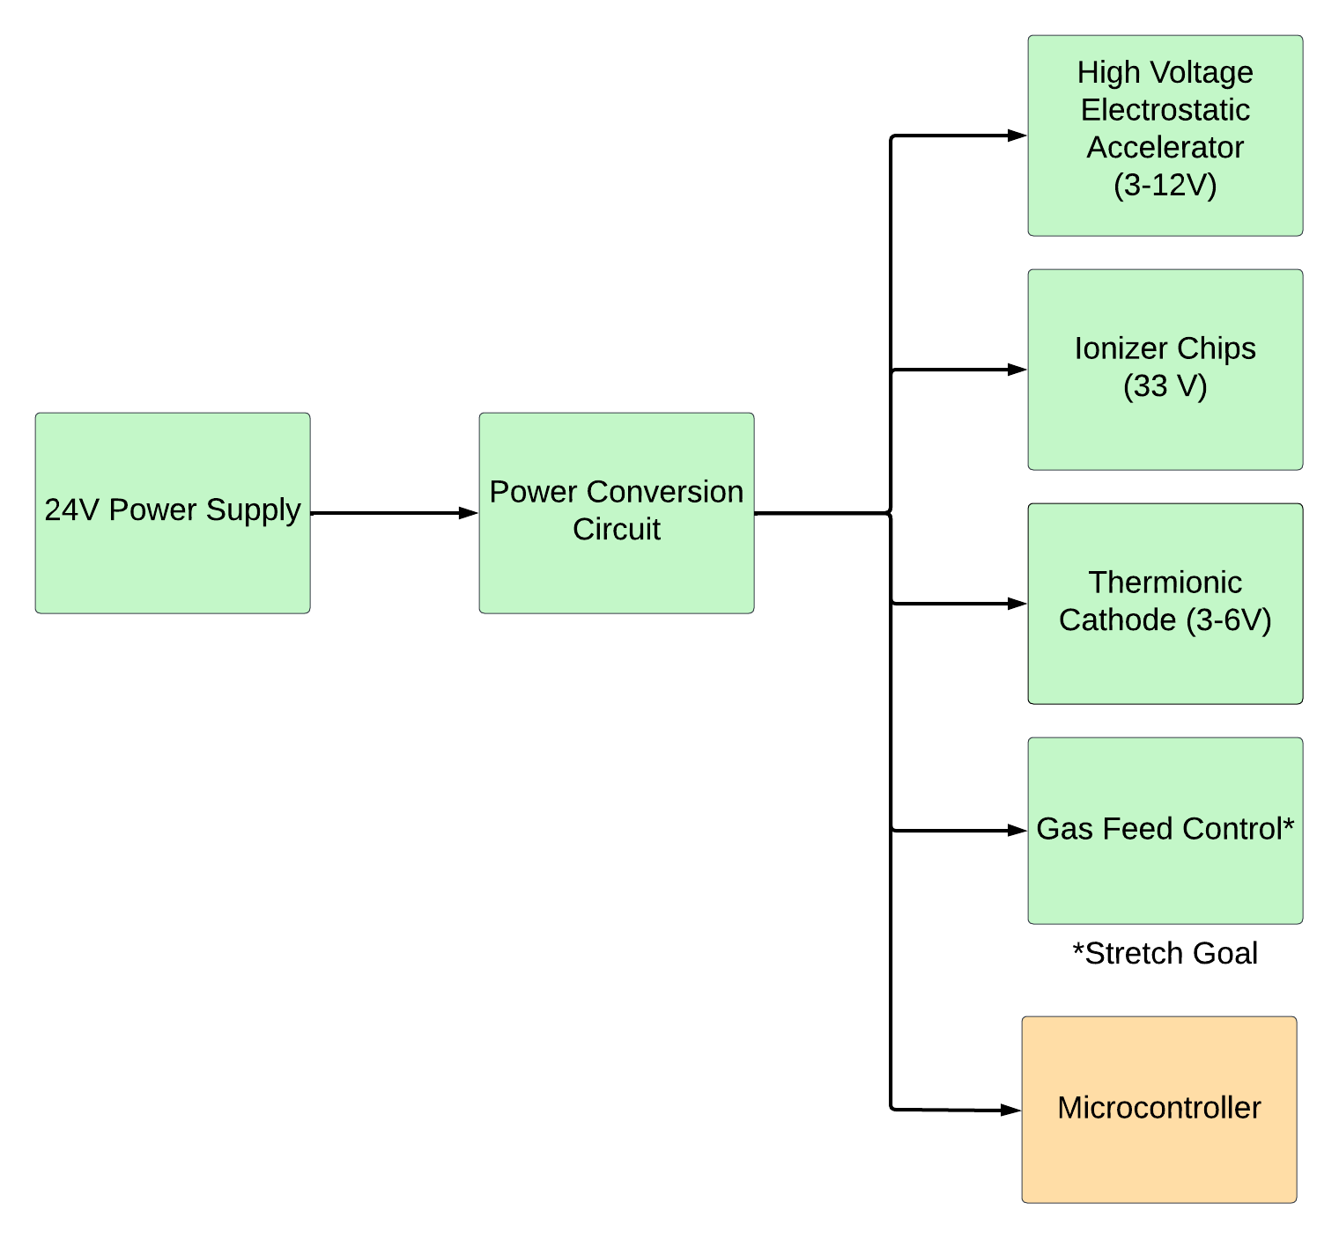

Figure 1: Breakdown of the Power Supply Subsystem

Figure 1 shows how the electrical interface of the RIOT Drive shall work. The 24V power supply shall go through a voltage converter and supply the voltages to the components as shown in Figure 1.

## Primary Input Power

The primary input power that would provide power to the CubeSat would be the spacecraft, assuming it would provide a voltage of 24 VDC. The power budget for the power supply shall be 25 W plus the power for the ionizer chip.

## Voltage and Current Levels

The power supply system shall be designed to output the required power and voltage criteria for the components within the CubeSat. The table below lists the necessary voltage and power requirements needed from the power supply circuit to provide power to the necessary components for the CubeSat.

| **Component** | **Voltage (V)** | **Current (A)** | **Power (W)** |
| --- | --- | --- | --- |
| High Voltage Electrostatic Accelerator | 3-12 | N/A | N/A |
| Thermionic Cathode | 3-6 | 0.3-1 | 1-3 |
| Ionizer Chips | 33 | 0.62 | ~21 |
| Digital-to-Analog Converter | 3.3 | 0.3 | 1 |
| Microcontroller | 3.3 | 0.3 | 1 |

Table 3: Voltage and Power for Components

## Signal Interfaces

The microcontroller shall be mounted on a PCB, and shall be wired to controls for the pulse charger, thermionic cathode, ionizer chips. The gas feed control will be compared by an ADC, and the output value will be transmitted to the gas feed control by the DAC.

## User Control Interface

No user interface was specified as required by the customer because the project is a prototype to prove that the RIOT Drive accelerator, shielding, and power circuit functions.

# Communications / Device Interface Protocols

## Prototype Interface

Our prototype will have parts of the system, such as the gas feed valve and high-voltage pulser, interface and communicate with the microcontroller. The circuit board will have test points for voltage probes in critical locations for the user to identify issues with the performance. A space-ready prototype would include a communication system which would be housed inside another CubeSat unit, and is outside the scope of our design.

## Use in Spacecraft

While our prototype will have an internal microcontroller, commercialized systems of the RIOT Drive would rely on the onboard computers of the spacecraft for system control.